EXPT NO:03 | EDA-DATA INSPECTION AND ANALYSIS

AIM:
To inspect and analyze the Global YouTube Statistics dataset using Exploratory Data Analysis (EDA) by examining its structure, statistical characteristics, missing values, and by filtering YouTube channels based on subscriber count and channel type.

ALGORITHM

PROCEDURE:
- Start the program.
- Import the required libraries Pandas, NumPy, and Matplotlib.
- Load the Global YouTube Statistics dataset using Pandas.
- Display the first five and last two records.
- Display the shape, column names, data types, and dataset information.
- Generate the statistical summary of numerical attributes.
- Check for missing values in the dataset.
- Create a DataFrame containing important YouTube attributes such as rank, channel name, subscribers, video views, country, channel type, and uploads.
- Filter channels having more than 100 million subscribers.
- Filter channels belonging to the Entertainment channel type.
- Display the filtered results.
- Generate suitable charts for subscriber distribution and channel-type distribution.
- Interpret the obtained results.
- End the program.

CODE:
import import pandas as pd
import numpy as np

import matplotlib.pyplot as plt
# Load Dataset

file_path = "Global YouTube Statistics.csv"
df = pd.read_csv( file_path, encoding="latin1", low_memory=False
# Select Important Columns
youtube_df = pd.DataFrame({

"Rank": df["rank"].head(5).tolist(
),

"Youtuber": df["Youtuber"].head(5).t olist
"Subscribers": df["subscribers"].head(5)
.tolist(),

"Video_Views": df["video views"].head(5).tolist(),
"Country": df["Country"].head(5).to list(),
"Channel_Type": df["channel_type"].head (5).tolist(),
"Uploads":

df["uploads"].head(5).tol ist()
})

print("Original DataFrame:")
display(youtube_df) # 1. First 5 Rows
print("\n1. First 5 rows:")

display(youtube_df.head ())
# 2. Last 2 Rows

print("\n2. Last 2 rows:")

display(youtube_df.tail( 2))
# 3. Shape print("\n3. Shape:")
print(youtube_df.shape)

# 4. Column Names

print("\n4. Column Names:")
print(youtube_df.column s)
# 6. Statistical Summary

print("\n6. Statistical Summary:")
display(youtube_df.desc ribe())
# 7. Missing Values

print("\n7. Missing Values:")
display(youtube_df.isnul l().sum())
# 8. Channels with > 100M Subscribers
print("\n8. Channels with more than 100 million subscribers:")

high_subscribers = df[

df["subscribers"] > 100000000
][[

"Youtuber", "subscribers", "video views", "Country", "channel_type"
]].head(10)

display(high_subscribers
)

# 9. Entertainment Channels
print("\n9. Entertainment Channels:")

entertainment = df[

df["channel_type"] == "Entertainment"
][[

"Youtuber", "subscribers", "video views", "Country", "channel_type"
]].head(10) display(entertainment)
# 10. Visualization - Subscribers
high_sub_all = df[

df["subscribers"] > 100000000
].sort_values(

"subscribers", ascending=False
).head(10)

plt.figure(figsize=(10, 5))
plt.bar( high_sub_all["Youtuber "],
high_sub_all["subscriber s"] / 1000000
)

plt.title("Channels with More Than 100M Subscribers")
plt.xlabel("YouTube Channel")
plt.ylabel("Subscribers (Millions)")

plt.xticks(rotation=45) plt.tight_layout() plt.show()
# 11. Channel Type Distribution
channel_counts = df[ "channel_type"
].value_counts().head(10
)

plt.figure(figsize=(9, 5))
plt.barh( channel_counts.index[::-
1],

channel_counts.values[::-
1]

)

plt.title("Top Channel Types")

plt.xlabel("Number of Channels")
plt.ylabel("Channel Type")
plt.tight_layout() plt.show()
# End

print("\nEDA inspection and filtering completed successfully.")

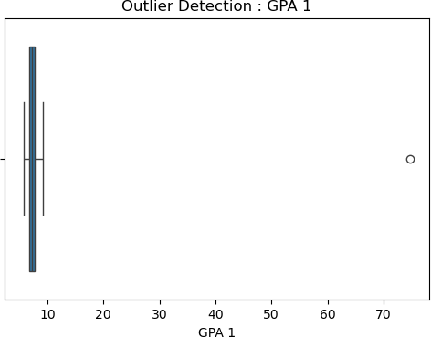

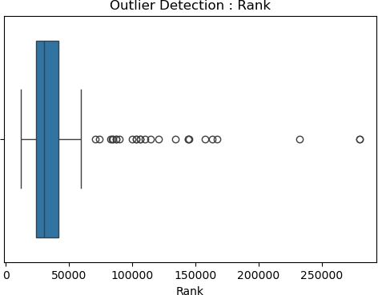

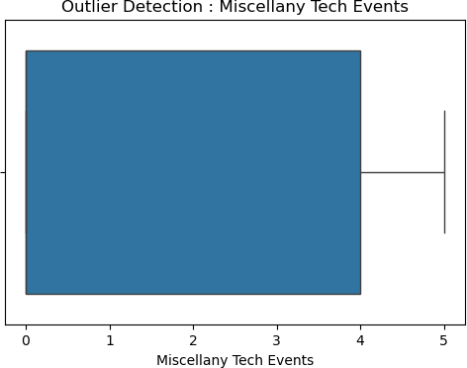

Result:

